



Test Cases /legal/

ReadySetResource.com

Contents

30.1 - Prepopulated Data 3

30.2 - Layout of Test Cases 3

30.3 - Test Log 3

30.4 - Test Cases Work Log 76

# 30.1 - Prepopulated Data

In order to make reliable testing, the system will be populated with data for up to 3 months previous for members of staff. To see a full list of all the prepopulated data, see ‘Company Data.pdf’ in the Testing directory.

# 30.2 - Layout of Test Cases

Each Test Case will have its own page which will include the following:

* The Test Case ID which links to the description of the case in the Test Procedure
* The attempt number (if the result fails, the test case will be reiterated after fixing)
* The action that will be taken to test the case
* If the test contains normal/extreme/exceptional testing
* The data used for testing (if any)
* The output that is expected of the case
* The actual output that the test provides
* The result of the test (Pass or Fail)
* If the result failed there will be:
  + A description of the reason for the failed error
  + The type of error (Syntax/Logic/Execution/Unknown)
  + Any action taken to remediate the error
* A screenshot of before the test
* A screenshot of after the test
* An additional screenshot may be provided for proof of pass/fail
* Any additional notes

# 30.3 - Test Log

To see the test log for the /legal/ section of the website, continue to next page.

Test Case ID: LR1 Attempt Number: 1

Action: User browses the /legal/ section

Comprehensive Test Type: Not Applicable

Test Data: Not Applicable

Expected Output: The website will display the index page of the legal controller and display legal information over what the website provides.

Actual Output: As expected

Result: Pass

Reason for fail (if applicable):

Error Type (if applicable):

Remediation (if applicable):

Screenshot Before:

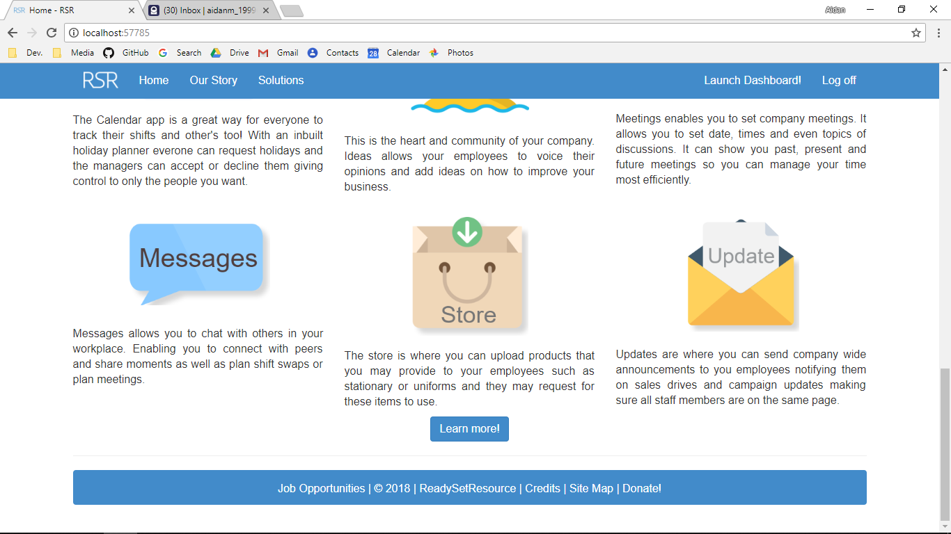

Screenshot After:

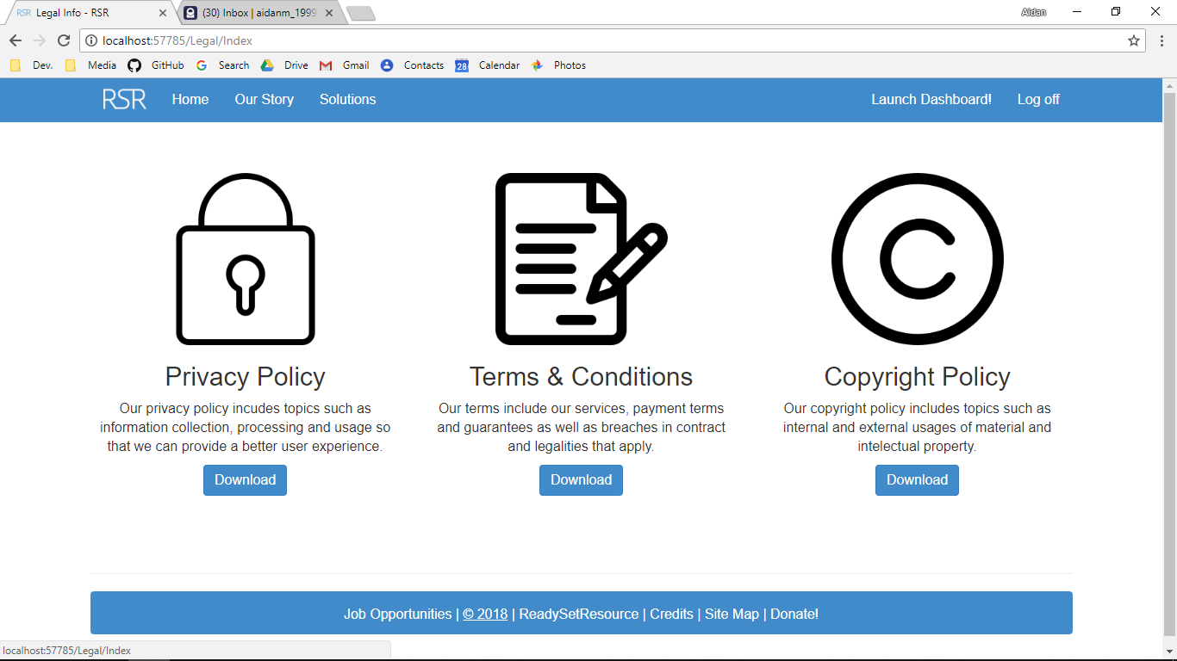

Additional Screenshot (if applicable):

Additional Notes (if applicable):

Test Case ID: HL1 Attempt Number: 1

Action: The user clicks on the Logo

Comprehensive Test Type: Not Applicable

Test Data: Not Applicable

Expected Output: The user is redirected to the home page

Actual Output: As expected

Result: Pass

Reason for fail (if applicable):

Error Type (if applicable):

Remediation (if applicable):

Screenshot Before:

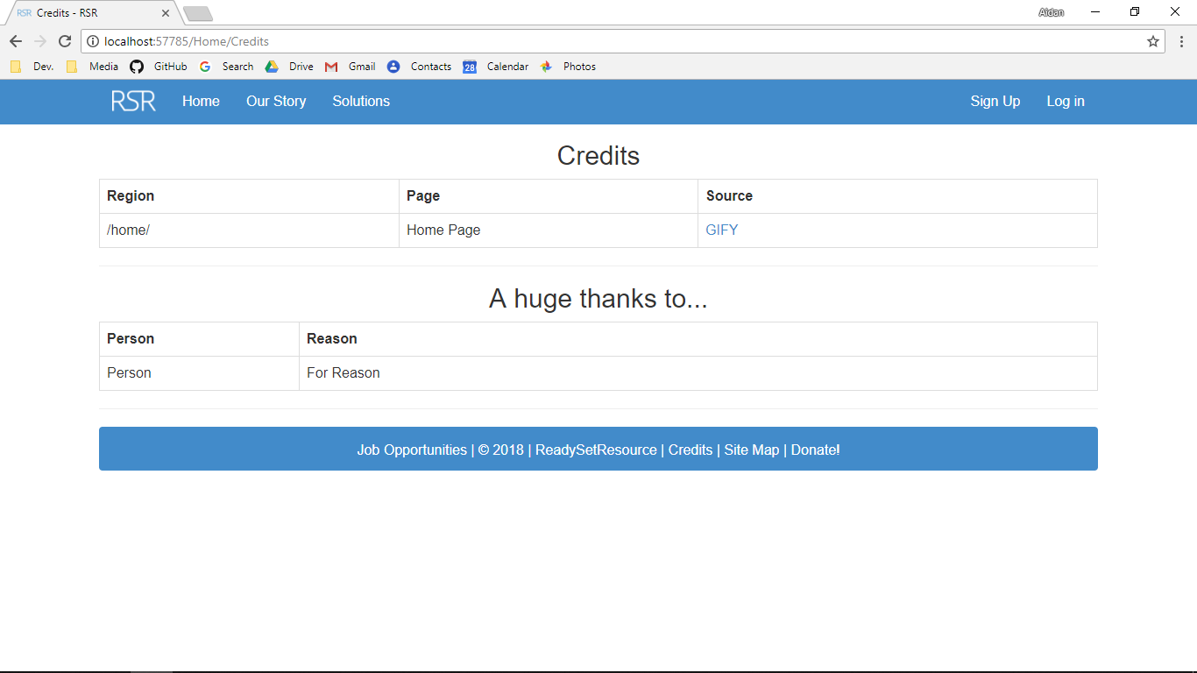

Screenshot After:

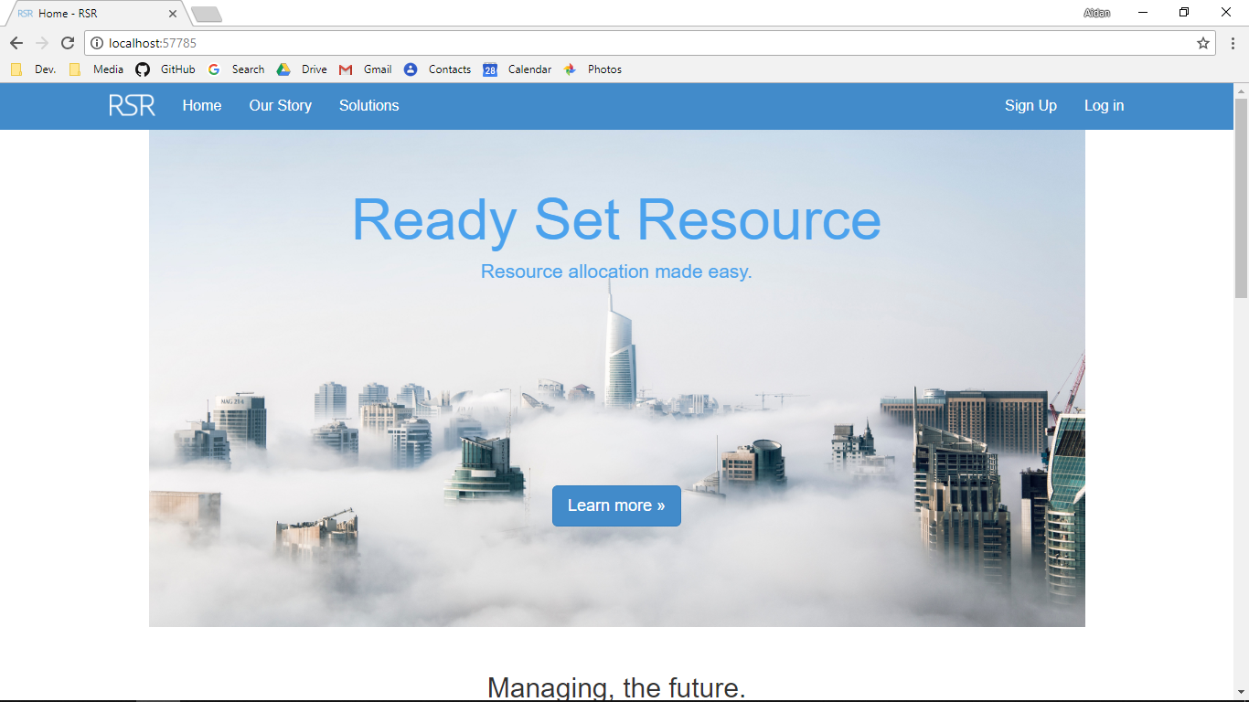

Additional Screenshot (if applicable):

Additional Notes (if applicable):

Test Case ID: LL2 Attempt Number: 1

Action: The user clicks on the home button

Comprehensive Test Type: Not Applicable

Test Data: Not Applicable

Expected Output: The user is redirected to the index page of the home controller

Actual Output: As expected

Result: Pass

Reason for fail (if applicable):

Error Type (if applicable):

Remediation (if applicable):

Screenshot Before:



Screenshot After:



Additional Screenshot (if applicable):

Additional Notes (if applicable):

Test Case ID: LL3 Attempt Number: 1

Action: The user clicks on the Our Story button

Comprehensive Test Type: Not Applicable

Test Data: Not Applicable

Expected Output: The user is redirected to the Our Story page in the home controller

Actual Output: As expected

Result: Pass

Reason for fail (if applicable):

Error Type (if applicable):

Remediation (if applicable):

Screenshot Before:



Screenshot After:

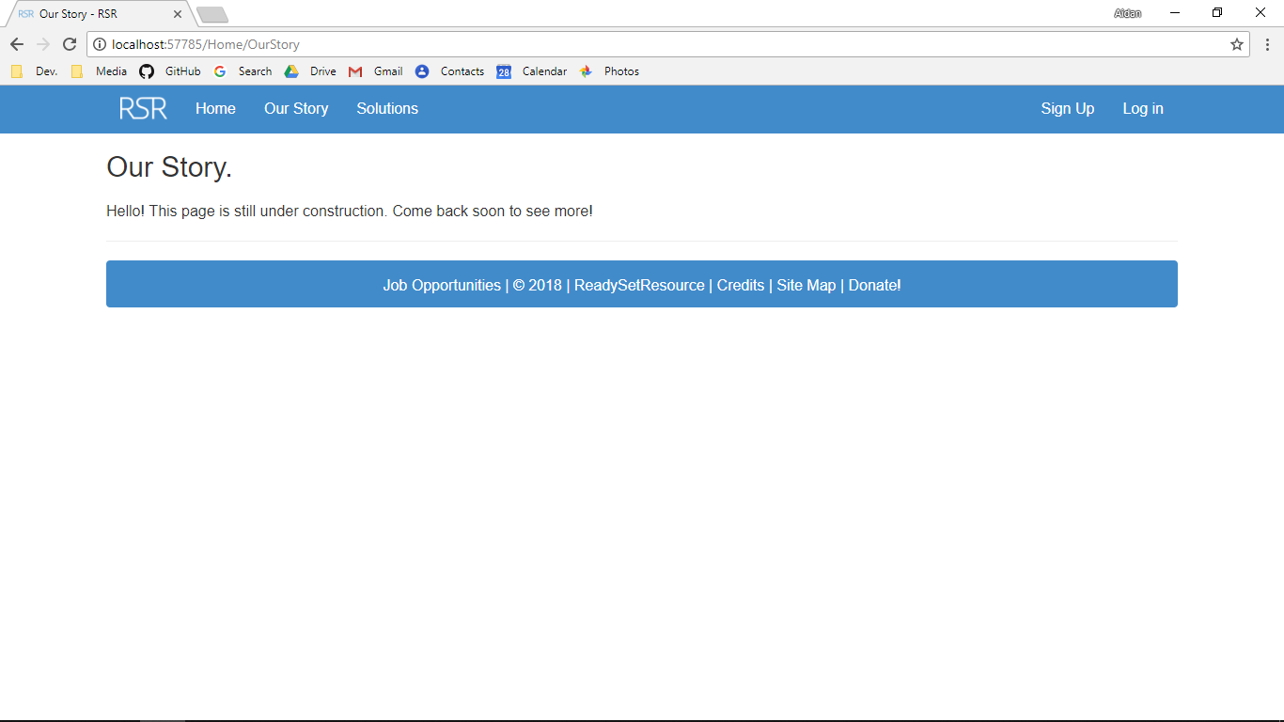

Additional Screenshot (if applicable):

Additional Notes (if applicable):

Test Case ID: LL4 Attempt Number: 1

Action: The user clicks on the Solutions button

Comprehensive Test Type: Not Applicable

Test Data: Not Applicable

Expected Output: The user is redirected to the solutions page

Actual Output: As expected

Result: Pass

Reason for fail (if applicable):

Error Type (if applicable):

Remediation (if applicable):

Screenshot Before:



Screenshot After:

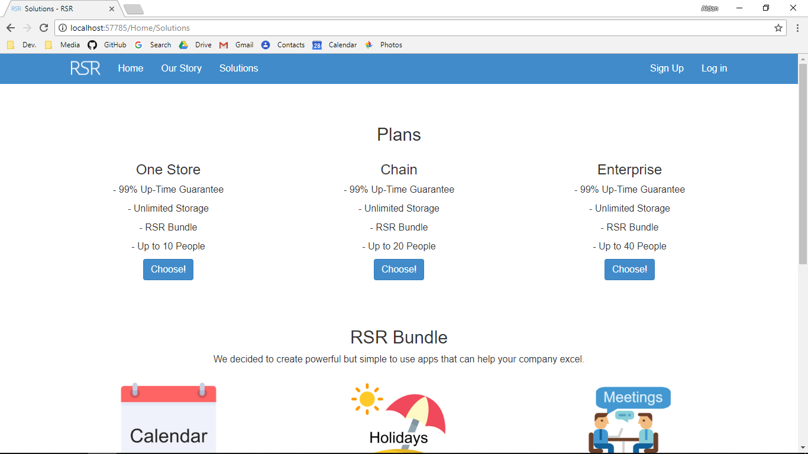

Additional Screenshot (if applicable):

Additional Notes (if applicable):

Test Case ID: LL5 Attempt Number: 1

Action: The user clicks on the Sign Up page

Comprehensive Test Type: Not Applicable

Test Data: Not Applicable

Expected Output: The user is redirected to the solutions page in the get controller

Actual Output: As expected

Result: Pass

Reason for fail (if applicable):

Error Type (if applicable):

Remediation (if applicable):

Screenshot Before:



Screenshot After:

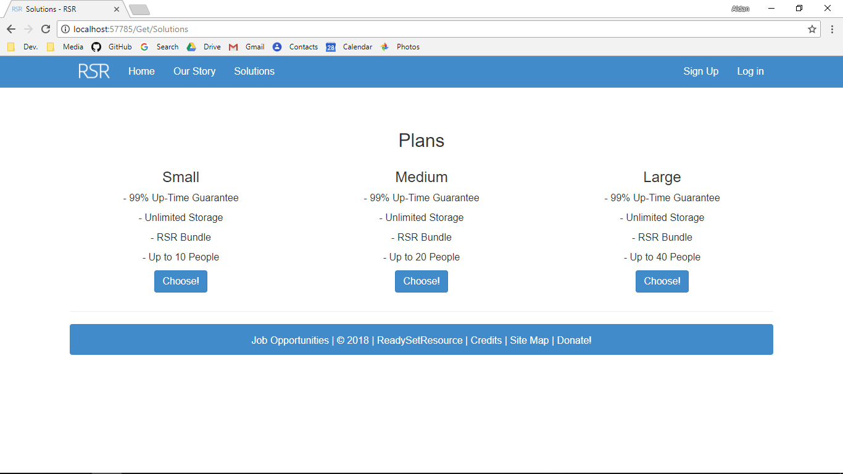

Additional Screenshot (if applicable):

Additional Notes (if applicable):

Test Case ID: LL6 Attempt Number: 1

Action: The user clicks on the log in page

Comprehensive Test Type: Not Applicable

Test Data: Not Applicable

Expected Output: The user is redirected to the log in page

Actual Output: As expected

Result: Pass

Reason for fail (if applicable):

Error Type (if applicable):

Remediation (if applicable):

Screenshot Before:



Screenshot After:

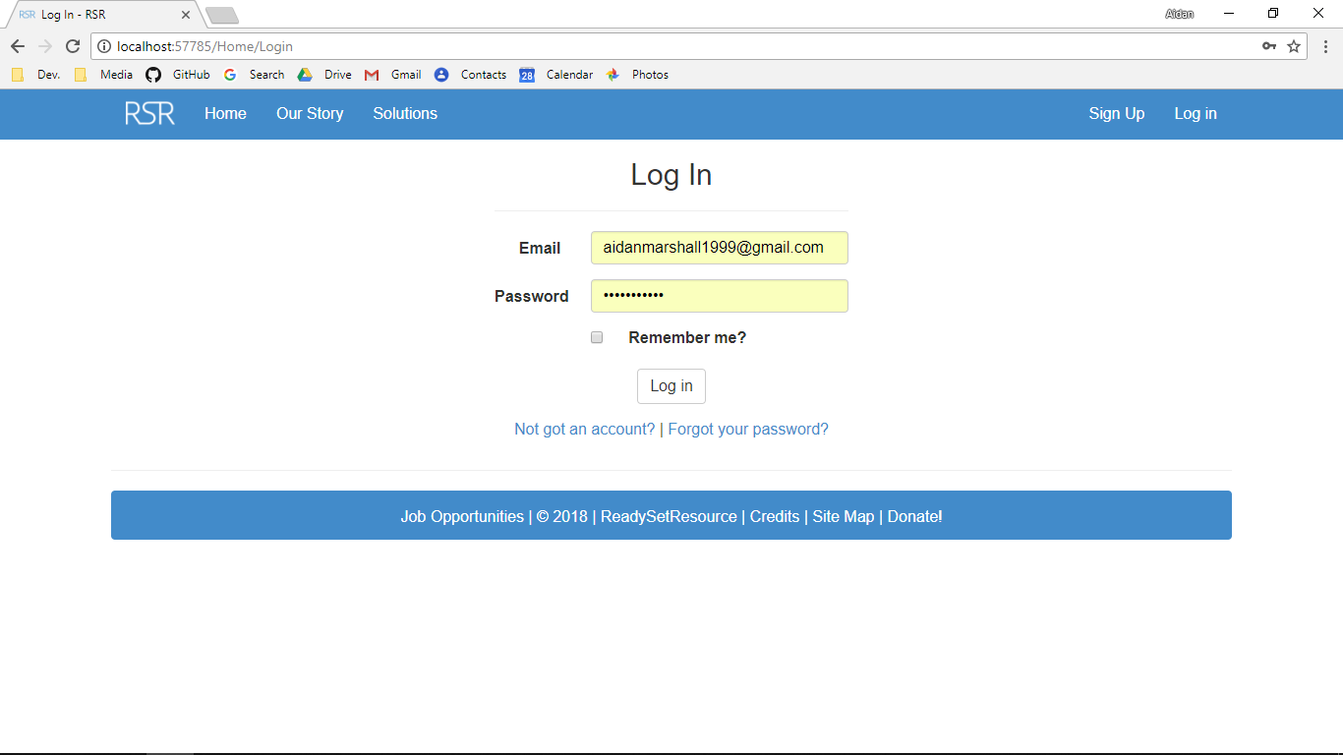

Additional Screenshot (if applicable):

Additional Notes (if applicable):

Test Case ID: LL7 Attempt Number: 1

Action: The user clicks on the Launch Dashboard button on the index page (must log in first)

Comprehensive Test Type: Not Applicable

Test Data: Not Applicable

Expected Output: The user is redirected to the index page in the dashboard controller

Actual Output: As expected

Result: Pass

Reason for fail (if applicable):

Error Type (if applicable):

Remediation (if applicable):

Screenshot Before:

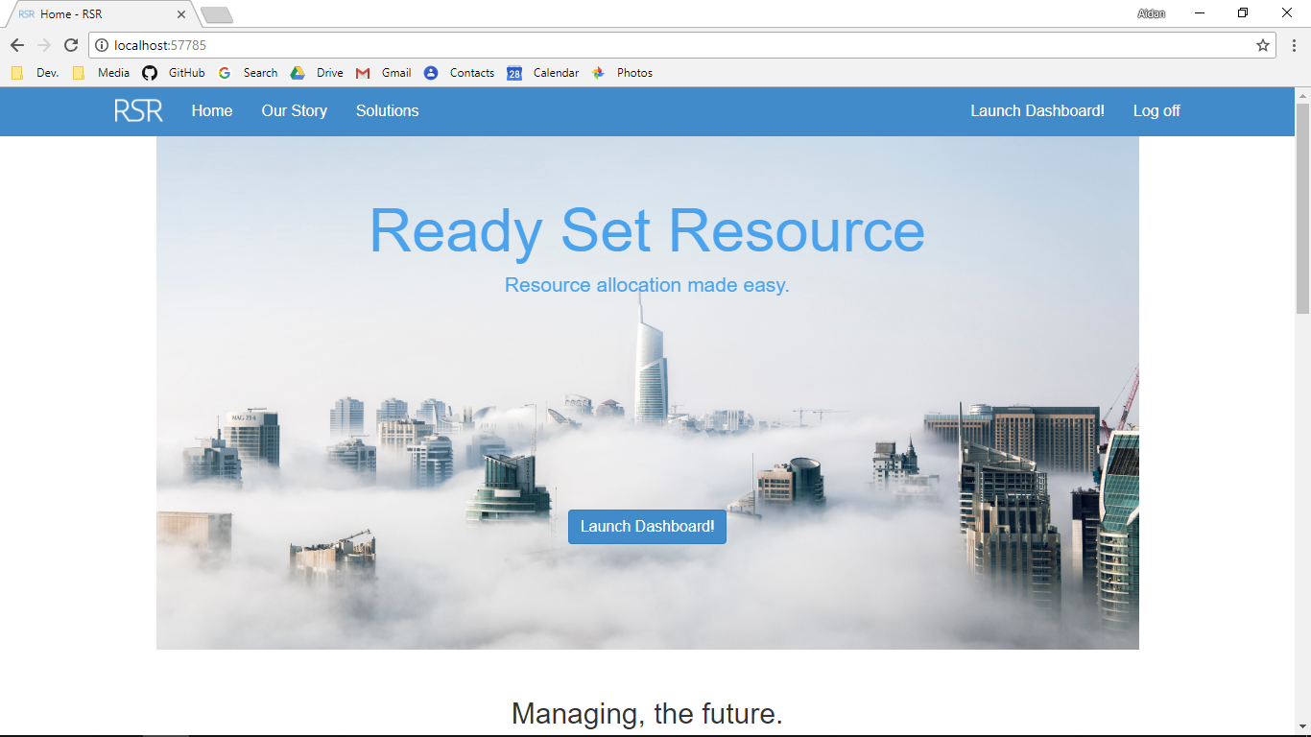

Screenshot After:

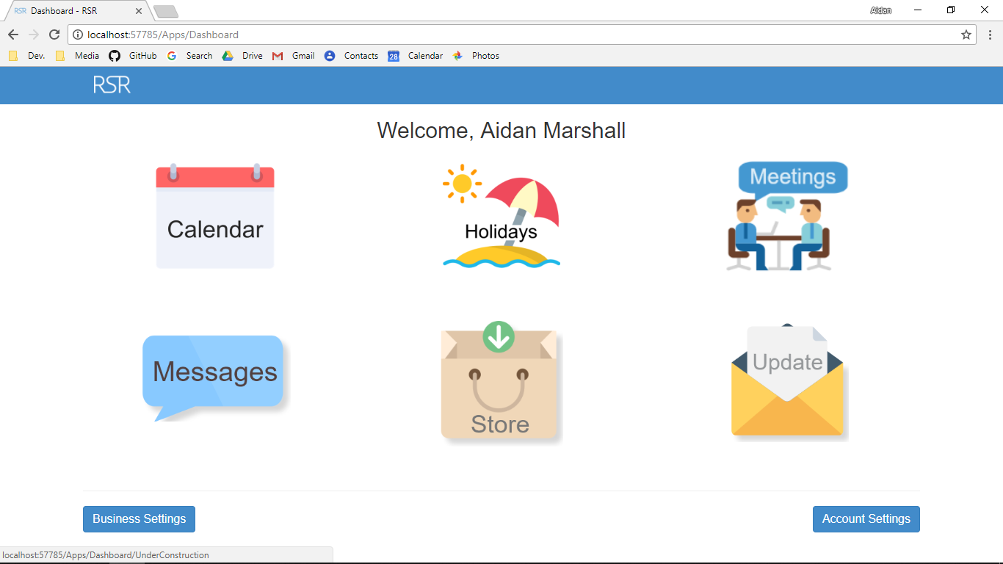

Additional Screenshot (if applicable):

Additional Notes (if applicable):

Test Case ID: LL8 Attempt Number: 1

Action: The user clicks on the Job Opportunities button

Comprehensive Test Type: Not Applicable

Test Data: Not Applicable

Expected Output: The user is redirected to the Job Opportunities page

Actual Output: As expected

Result: Pass

Reason for fail (if applicable):

Error Type (if applicable):

Remediation (if applicable):

Screenshot Before:

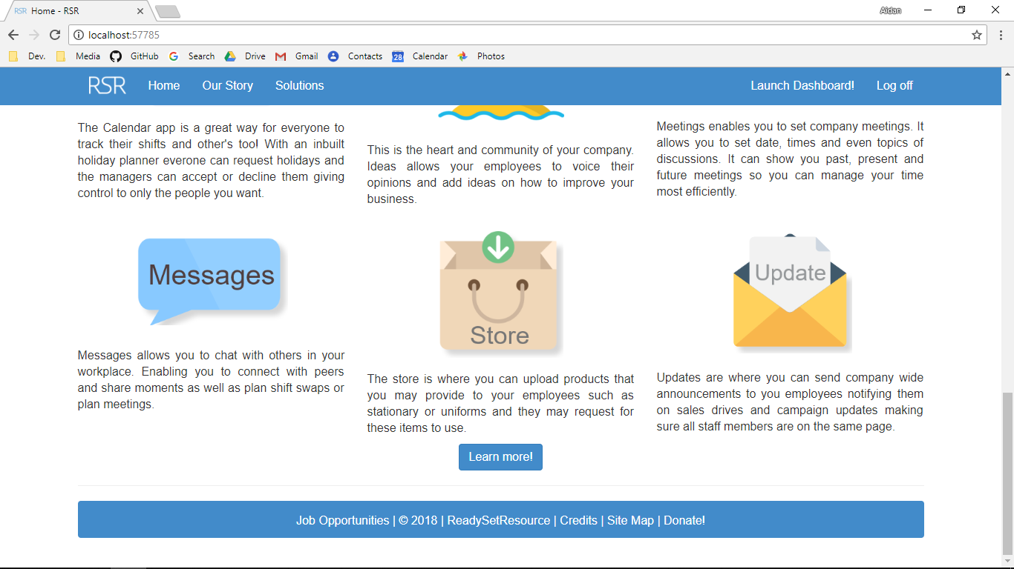

Screenshot After:

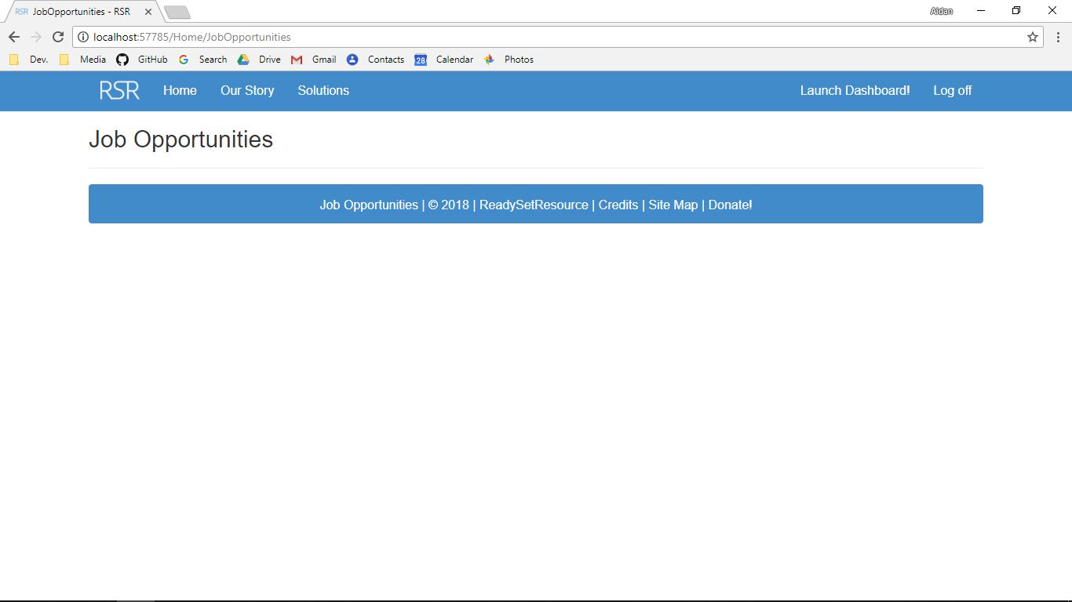

Additional Screenshot (if applicable):

Additional Notes (if applicable):

Test Case ID: LL9 Attempt Number: 1

Action: The user clicks on the 2018 button

Comprehensive Test Type: Not Applicable

Test Data: Not Applicable

Expected Output: The user is redirected to the legal index page

Actual Output: As expected

Result: Pass

Reason for fail (if applicable):

Error Type (if applicable):

Remediation (if applicable):

Screenshot Before:

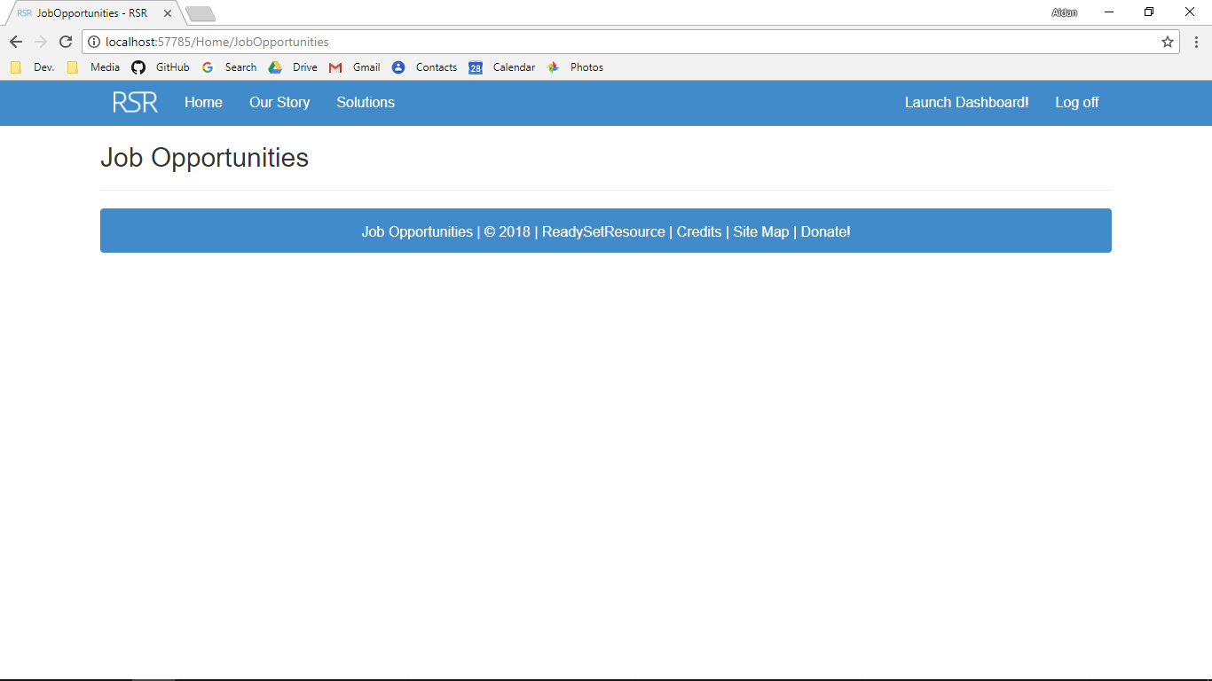

Screenshot After:

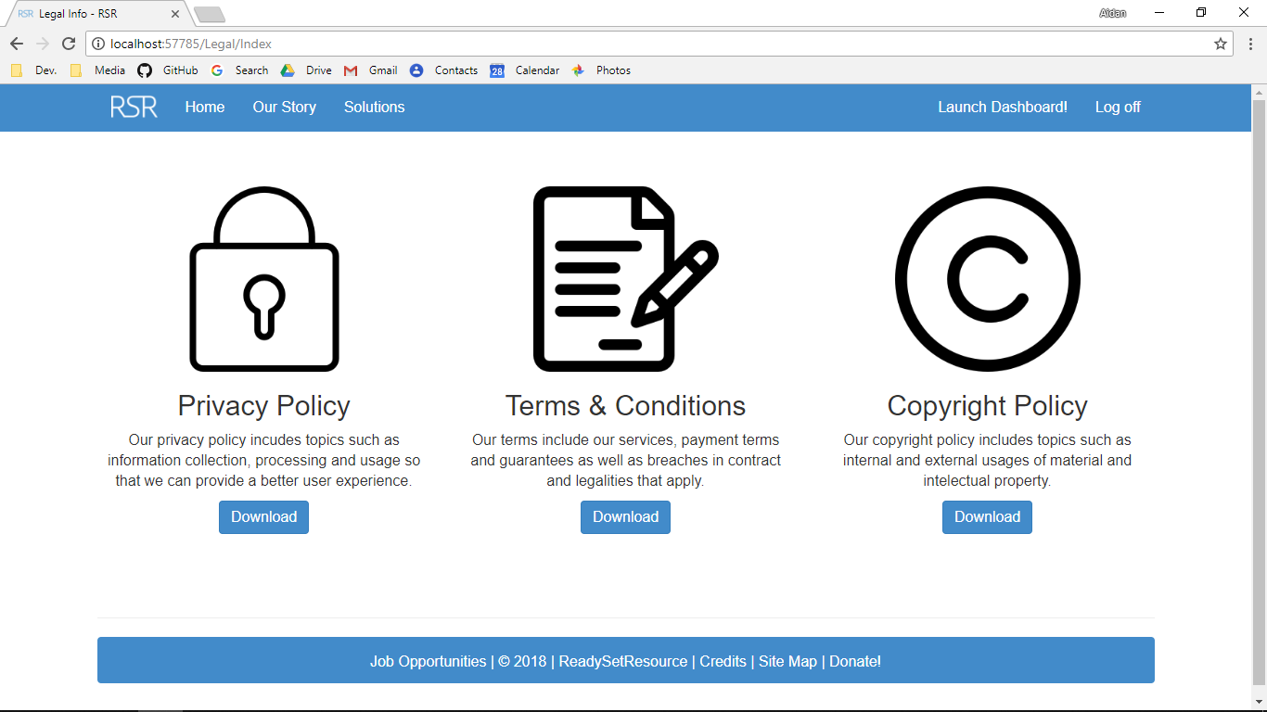

Additional Screenshot (if applicable):

Additional Notes (if applicable):

Test Case ID: LL10 Attempt Number: 1

Action: The user clicks on ReadySetResource button

Comprehensive Test Type: Not Applicable

Test Data: Not Applicable

Expected Output: The user is redirected to the index page in the home controller

Actual Output: As expected

Result: Pass

Reason for fail (if applicable):

Error Type (if applicable):

Remediation (if applicable):

Screenshot Before:



Screenshot After:



Additional Screenshot (if applicable):

Additional Notes (if applicable):

Test Case ID: LL11 Attempt Number: 1

Action: The user clicks on the credits button

Comprehensive Test Type: Not Applicable

Test Data: Not Applicable

Expected Output: The user is redirected to the credits page

Actual Output: As expected

Result: Pass

Reason for fail (if applicable):

Error Type (if applicable):

Remediation (if applicable):

Screenshot Before:

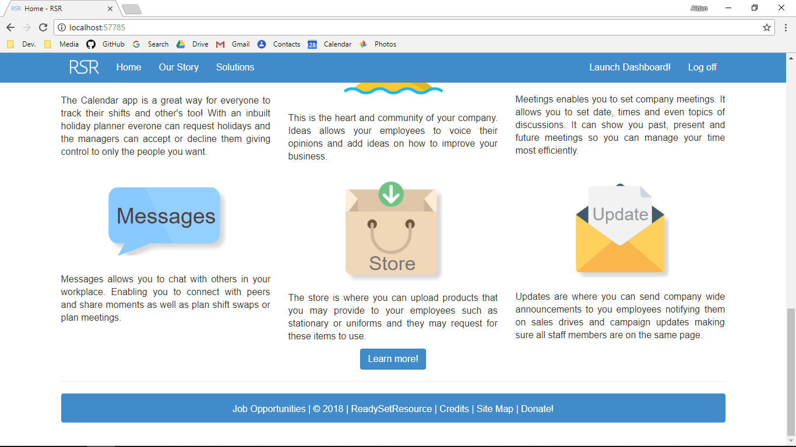

Screenshot After:

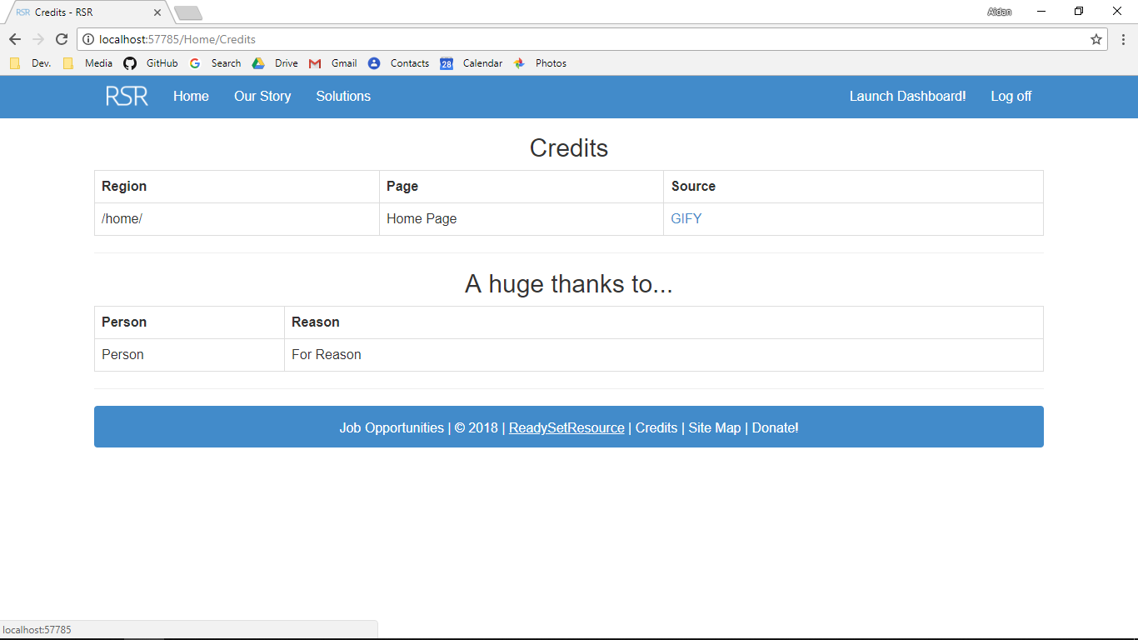

Additional Screenshot (if applicable):

Additional Notes (if applicable):

Test Case ID: LL12 Attempt Number: 1

Action: The user clicks on the Site Map Button

Comprehensive Test Type: Not Applicable

Test Data: Not Applicable

Expected Output: The user is redirected to the site map page

Actual Output: As expected

Result: Pass

Reason for fail (if applicable):

Error Type (if applicable):

Remediation (if applicable):

Screenshot Before:



Screenshot After:

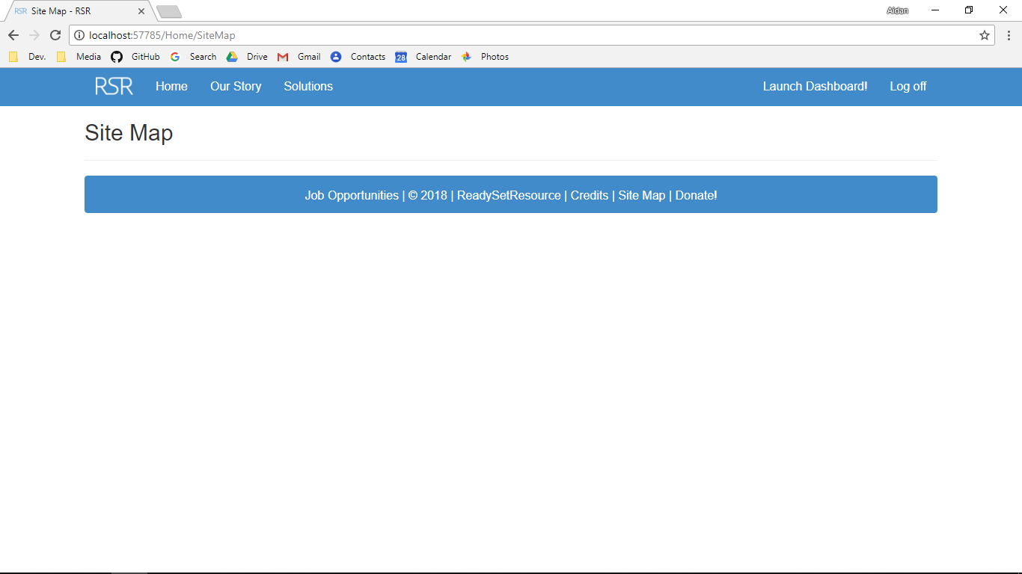

Additional Screenshot (if applicable):

Additional Notes (if applicable):

Test Case ID: LL13 Attempt Number: 1

Action: The user clicks on the Donate! button

Comprehensive Test Type: Not Applicable

Test Data: Not Applicable

Expected Output: The user is redirected to the donate page

Actual Output: As expected

Result: Pass

Reason for fail (if applicable):

Error Type (if applicable):

Remediation (if applicable):

Screenshot Before:



Screenshot After:

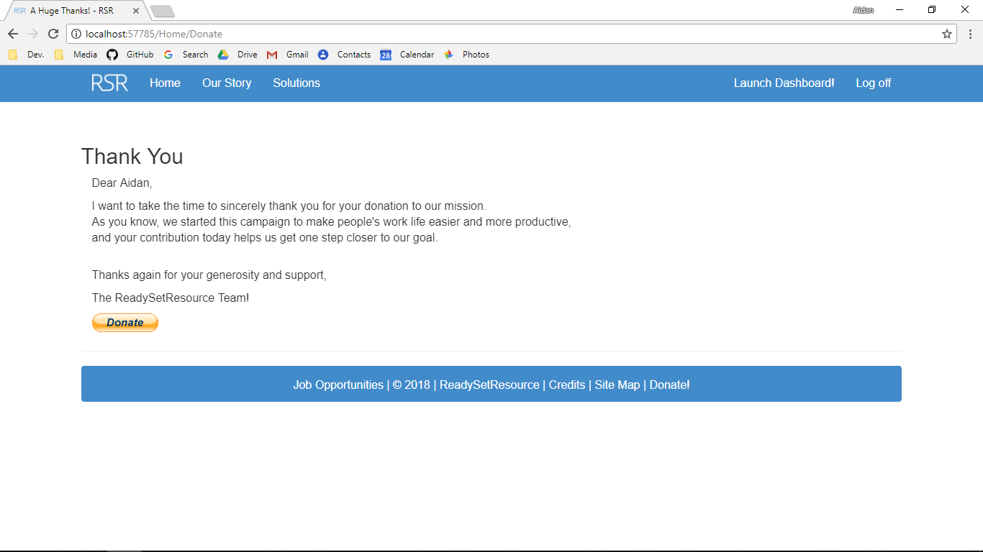

Additional Screenshot (if applicable):

Additional Notes (if applicable):

Test Case ID: LA1 Attempt Number: 1

Action: The user clicks the first download button

Comprehensive Test Type: Not Applicable

Test Data: Not Applicable

Expected Output: A new screen with a PDF is displayed

Actual Output: As expected

Result: Pass

Reason for fail (if applicable):

Error Type (if applicable):

Remediation (if applicable):

Screenshot Before:

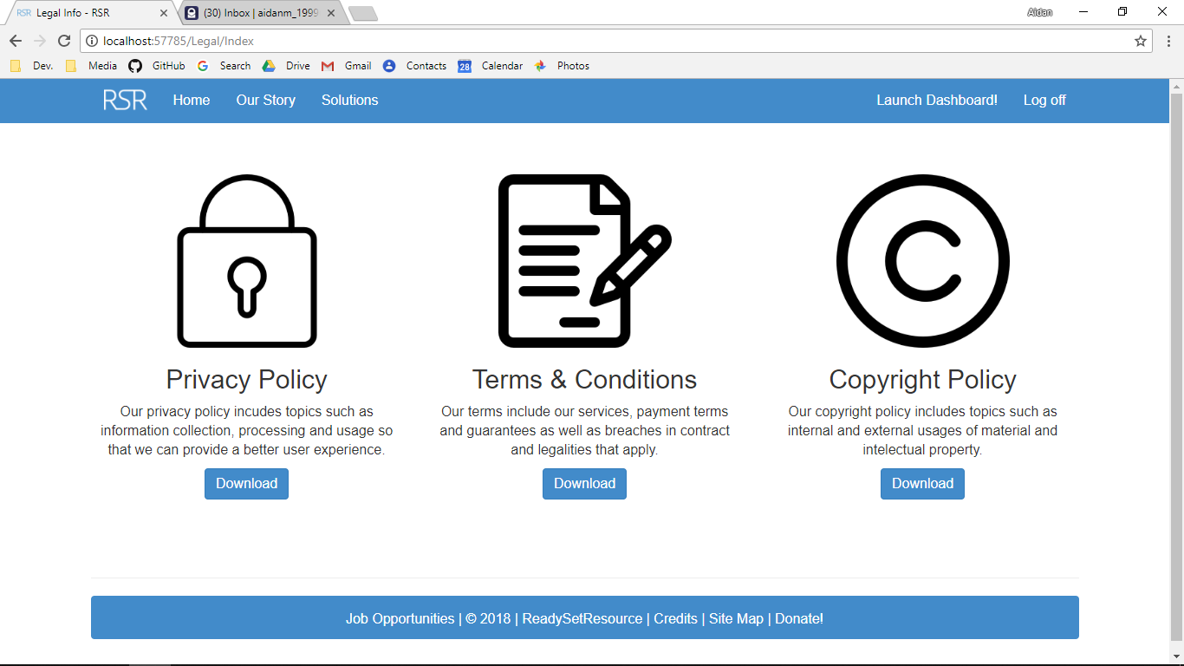

Screenshot After:

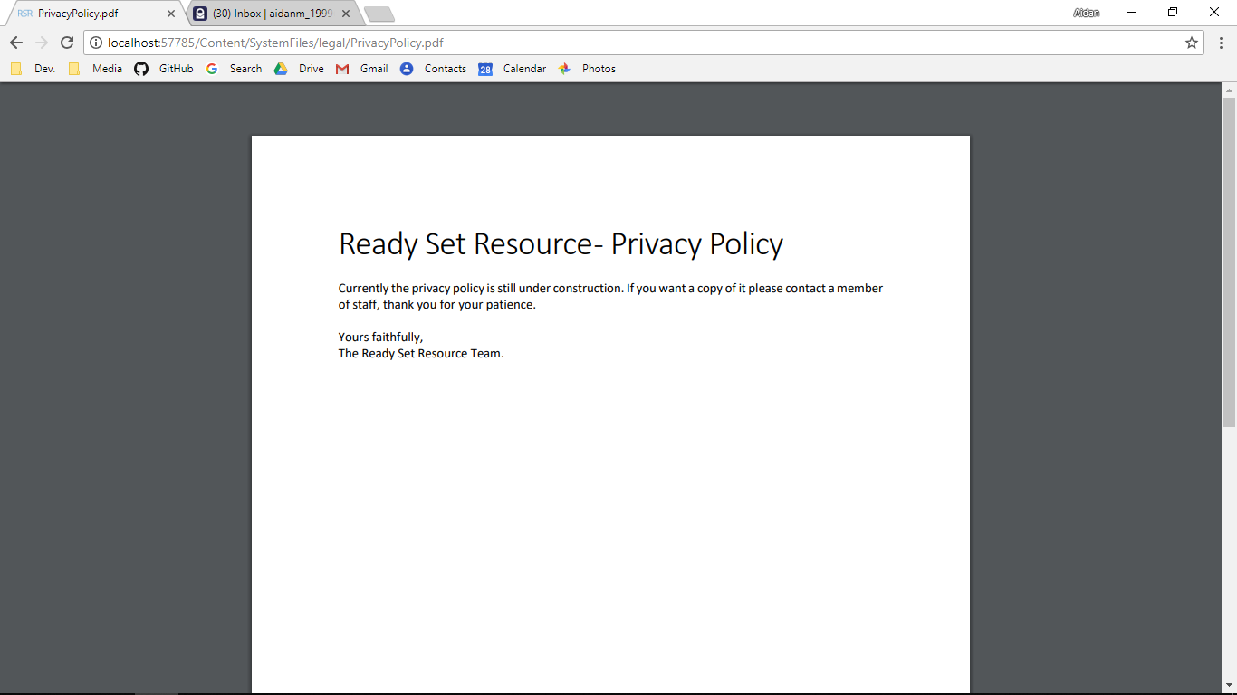

Additional Screenshot (if applicable):

Additional Notes (if applicable):

Test Case ID: LA2 Attempt Number: 1

Action: The user clicks the first download button

Comprehensive Test Type: Not Applicable

Test Data: Not Applicable

Expected Output: A new screen with a PDF is displayed

Actual Output: As expected

Result: Pass

Reason for fail (if applicable):

Error Type (if applicable):

Remediation (if applicable):

Screenshot Before:



Screenshot After:

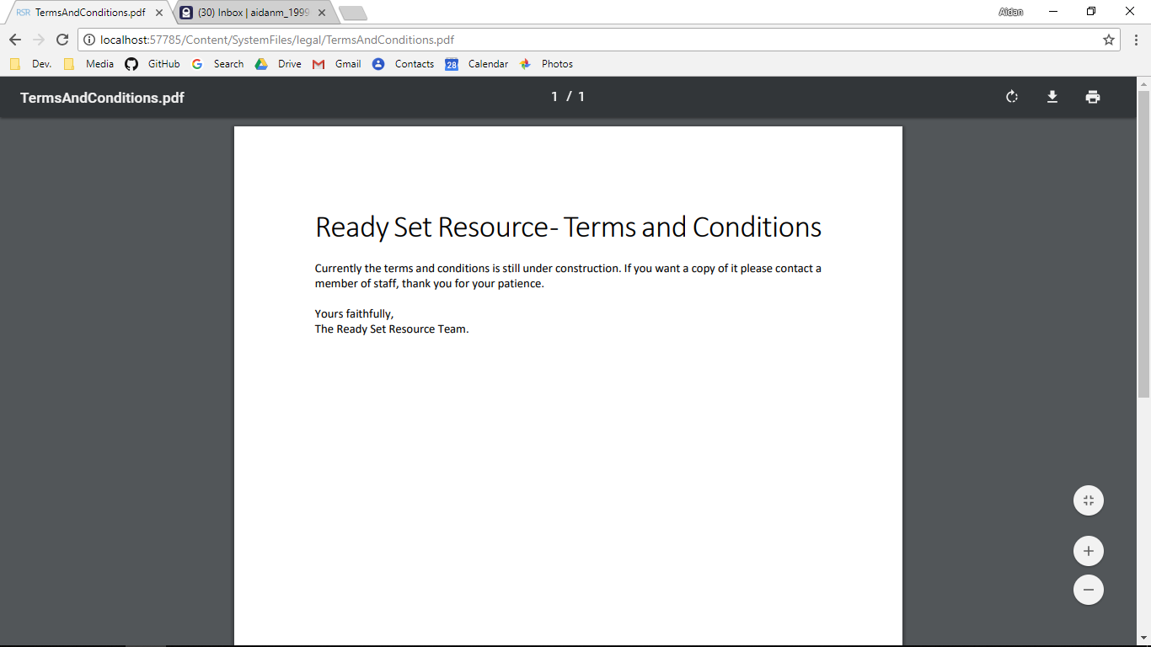

Additional Screenshot (if applicable):

Additional Notes (if applicable):

Test Case ID: LA2 Attempt Number: 1

Action: The user clicks the first download button

Comprehensive Test Type: Not Applicable

Test Data: Not Applicable

Expected Output: A new screen with a PDF is displayed

Actual Output: As expected

Result: Pass

Reason for fail (if applicable):

Error Type (if applicable):

Remediation (if applicable):

Screenshot Before:



Screenshot After:

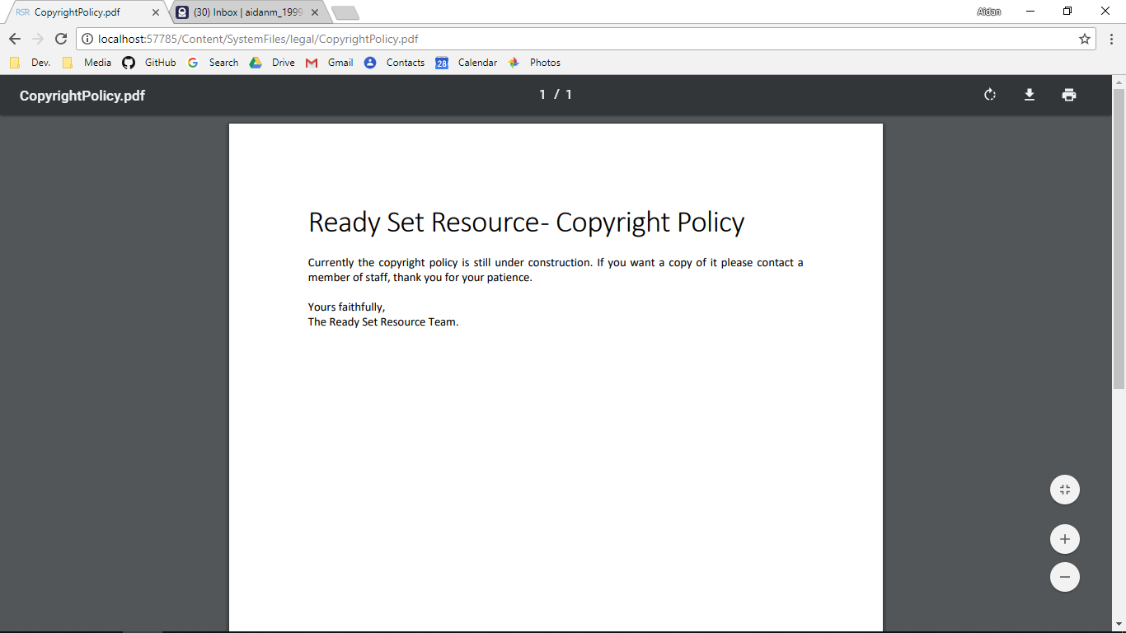

Additional Screenshot (if applicable):

Additional Notes (if applicable):

# 30.4 - Test Cases Work Log

| Entry | Description | Person | Date | Mins Spent |
| --- | --- | --- | --- | --- |
| 1 | Formatted the document | Aidan Marshall | 29/5/18 | 2 |
| 2 | Wrote the prepopulated data section | Aidan Marshall | 29/5/18 | 2 |
| 3 | Described the layout of the test cases | Aidan Marshall | 29/5/18 | 2 |
| 4 | Wrote the test log | Aidan Marshall | 29/5/18 | 40 |
| 5 | Completed the test cases | Aidan Marshall | 29/5/18 | 39 |
| 85 | | | | |